INF1103 Lab 7 Screenshots
GITHub Repository: https://github.com/SYnthestic/INF1103lab2

Scenario | Screenshot
Docker Build | 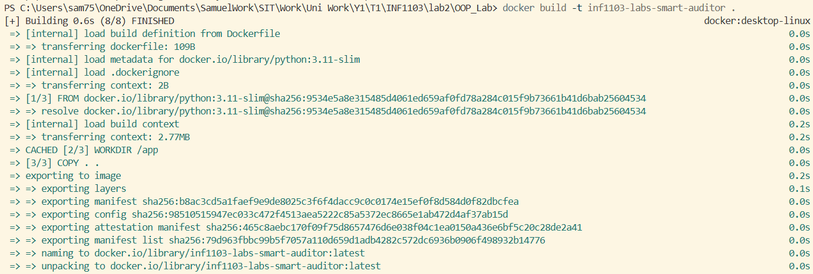
Docker Run | 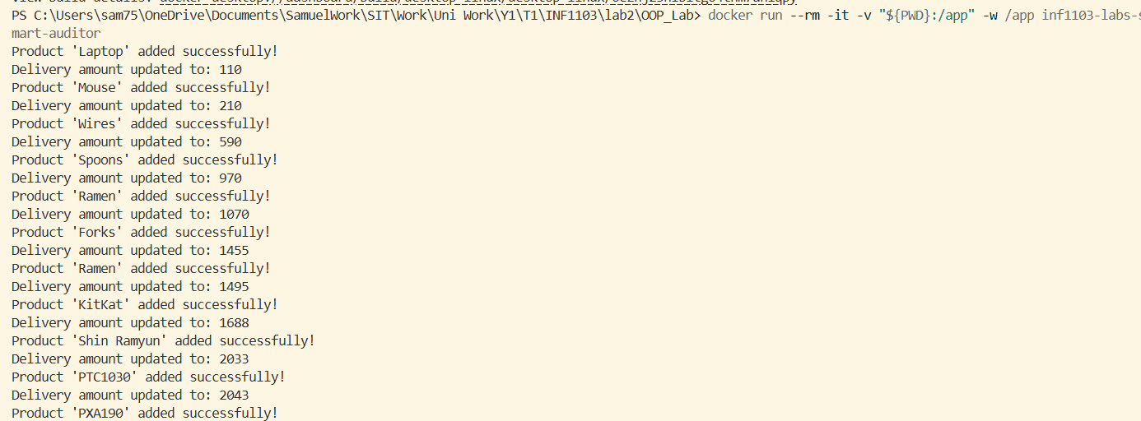
Docker images | 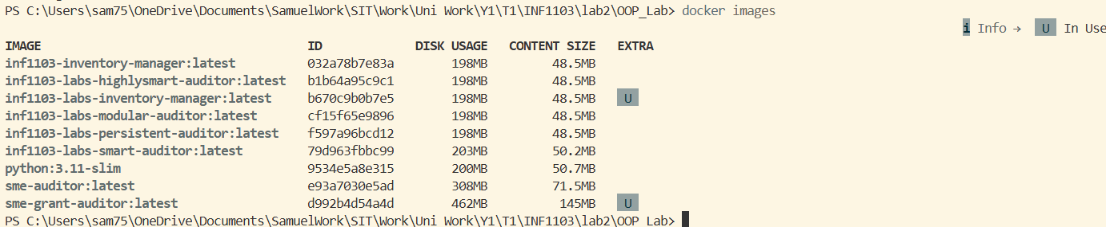
Option 1 | 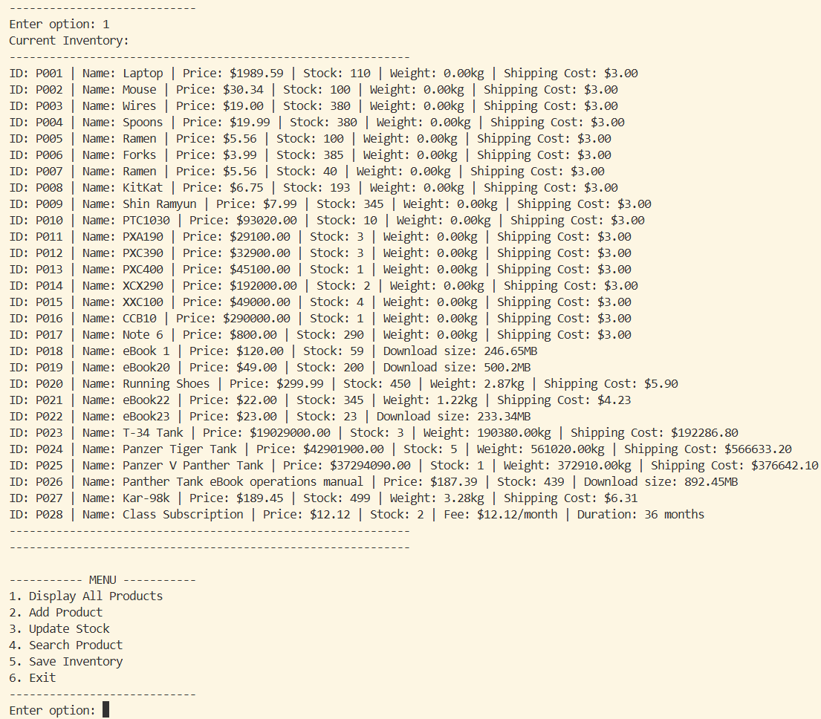
Option 2 | 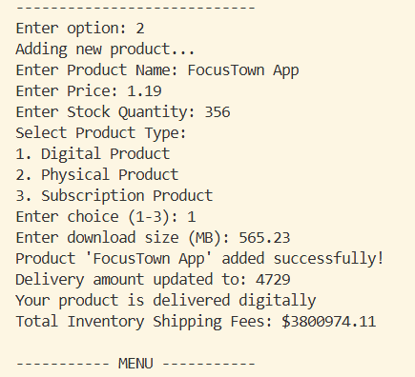
Option 3 | 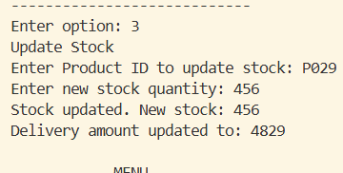
Option 4 | 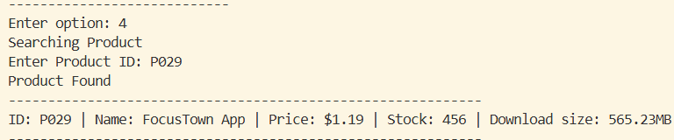
Option 5 and 6 | 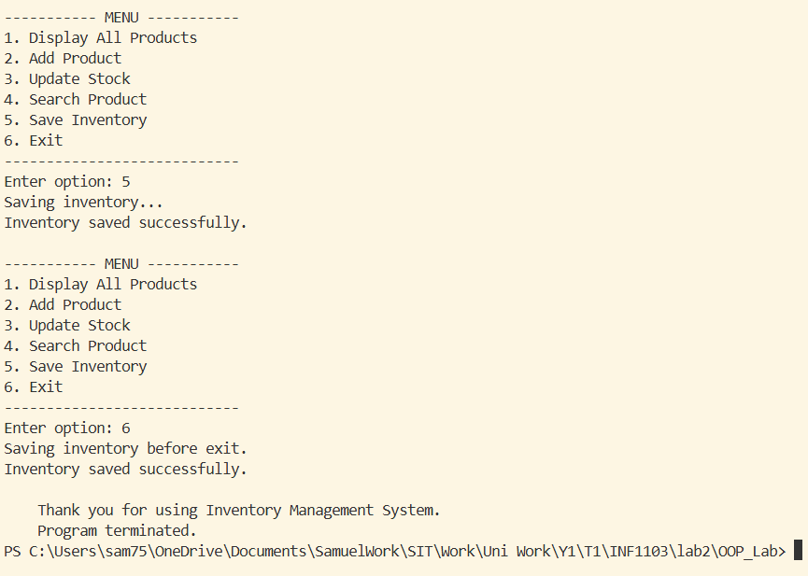
UML Class Diagram (png) | 